**Ideation Phase**

**Define the Problem Statements**

|  |  |
| --- | --- |
| Date | 18-June-2025 |
| Team ID | LTVIP2025TMID53008 |
| Project Name | Shop Smart |
| Maximum Marks | 2 Marks |

**Customer Problem Statement :**

In today's fast-paced world, customers struggle with the inconvenience of traditional grocery shopping, such as long queues, limited store hours, inconsistent product availability, and the lack of time to physically visit multiple stores. They seek a solution that allows them to browse a wide variety of high-quality groceries, compare prices, and order essentials from the comfort of their homes at any time.

Customers want an easy-to-use platform that ensures timely delivery, fresh produce, transparent pricing, and a seamless checkout experience. Many are also looking for personalized recommendations, real-time stock updates, and flexible delivery options that fit their lifestyle.

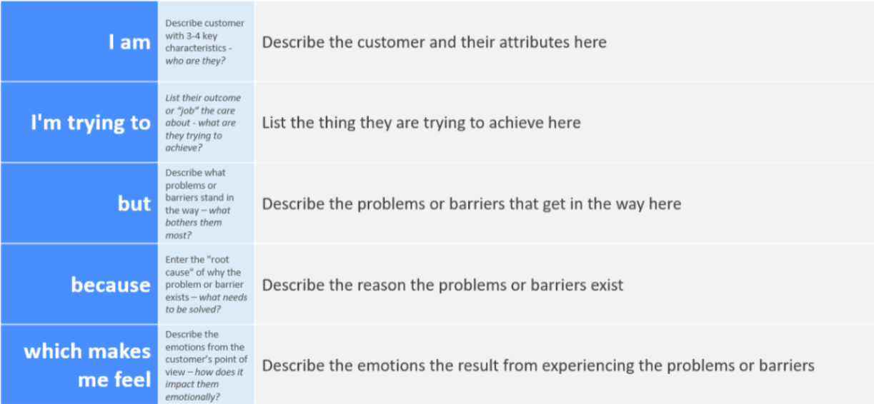

Reference: <https://miro.com/templates/customer-problem-statement/>

|  |  |  |  |  |  |
| --- | --- | --- | --- | --- | --- |
| **Problem Statement (PS)** | **I am (User)** | **I’m trying to** | **But** | **Because** | **Which makes me feel** |
| PS-1 | a busy professional | order groceries conveniently | I can't always find time to visit stores | my work schedule is unpredictable | frustrated and stressed |
| PS-2 | a health-conscious parent | get fresh and quality produce delivered | the online platforms don’t guarantee quality | I need trusted and consistent product quality | anxious and dissatisfied |